Project Motivation and Business Analysis

VegaOnline recently conducted a user activity study in an attempt to understand why users leave their online casino, and to determine methods of decreasing the chance of users logging off. The results from the first quarter suggest that many users are willing to continue gambling for several hours, with a regular increase in likelihood to log off as time progresses. This is illustrated below in figure x.x.

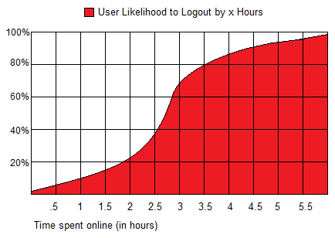
Figure X.X - User likelihood to logout after being active on VegaOnline's casinos for an extended period of time.

Along with the likelihood to logout, analysts at VegaOnline also determined that the major source of users logging off is due to a financial loss of a approximately 300% of the average winnings/losses the player has been experiencing every round. In fact, a user losing by a significant amount increases their likelihood to logout by nearly 35%. As it is more profitable for VegaOnline to keep their users online than to win by 300% of the average winnings/losses, VegaOnline is implementing an AI adjustment algorithm that will reduce the frequency of VegaOnline winning by more than 300% of the average winnings/losses.

VegaOnline has picked Group2Name to develop their software due to their past success in simulation software. After a short negotiation phase, the agreement for the project was that Group2Name would be given any and all profits generated from the development of an AI adjustment algorithm for a six month period. This allowed VegaOnline to hire a software developer without any initial investments in the software.

Group2Name has concluded that the best solution for developing an AI adjustment algorithm would be to create a simulation in order to compare the average winnings of one AI selection vs. any other AI selection, and to assist in determining which strategy the other player is using, as all of this data will be crucial for the development of an AI adjustment algorithm.

**NOTES** - I'll have to find a way to come up with a fake average winnings per hand in order to test the 300%.

